Monitoring Analyst Test – CloudWalk
“Where there is data smoke, there is business fire.” — Thomas Redman
1. Overview
This challenge simulates real scenarios faced by the Monitoring team at CloudWalk.
The objective is to:
- Identify anomalous behaviors in transactional and checkout data
- Design a simple real-time monitoring and alerting system
- Explain decisions, models, and assumptions clearly
The solution is divided into two main parts:
- Exploratory data analysis (EDA) of checkout behavior
- Design and implementation of a transaction monitoring and alert system

2. Challenge 3.1 – Anomaly Analysis on Checkout Data
2.1 Dataset Description
Files used:
- checkout_1.csv
- checkout_2.csv
Each dataset contains:
- Number of POS sales per hour (today)
- Comparison with:
  - yesterday
  - same_day_last_week
  - avg_last_week
  - avg_last_month
This structure allows baseline comparison and detection of unusual deviations.

2.2 Exploratory Analysis
Key Observation – Checkout 1
When comparing Today vs Average of Last Week, we observe:
- Strong spikes starting around 09h–10h
- Sales volumes are significantly higher than historical averages
- The deviation persists throughout business hours
📈 This indicates a positive anomaly:
- Possible marketing campaign
- POS rollout
- Seasonal or external event
- Data ingestion duplication (needs validation)
Example visualization generated:
- X-axis: Hour of day
- Y-axis: Number of transactions
- Lines:
  - Today
  - Average of last week
The sustained deviation (not just a single spike) suggests systemic behavior, not random noise.

Checkout 2 Comparison
Checkout 2 shows:
- More stable behavior
- Smaller variance between today and historical averages
- No persistent anomalies
👉 This strengthens the hypothesis that Checkout 1 anomaly is localized, not platform-wide.

2.3 Example SQL Query Used for Analysis
SELECT
time,
today,
avg_last_week,
(today - avg_last_week) AS deviation
FROM checkout_1
ORDER BY time;
This query highlights:
- Absolute deviation per hour
- Ideal for alert thresholds (e.g., deviation > X%)

2.4 Conclusion – Checkout Analysis
- Checkout 1 presents a clear anomalous behavior
- The anomaly is:
  - Sustained
  - Time-bound
  - Statistically significant vs baseline
- Requires monitoring but not necessarily an incident unless correlated with failures or reversals

3. Challenge 3.2 – Transaction Monitoring & Alert System
3.1 Dataset Description
Files used:
- transactions.csv
- transactions_auth_codes.csv
Data granularity:
- Per minute
- Status-based counts:
  - approved
  - failed
  - denied
  - reversed

3.2 Monitoring Objective
Detect abnormal increases in:
- ❌ Failed transactions
- 🔄 Reversed transactions
- ⛔ Denied transactions
Compared against:
- Recent baseline
- Moving averages
- Historical patterns
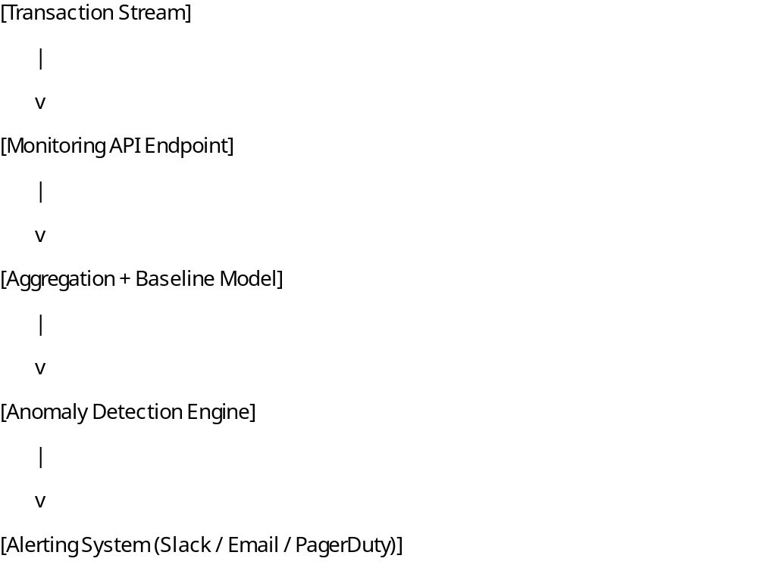

3.3 Architecture Proposal

3.4 Endpoint Definition (Example)
POST /monitor/transaction
Payload
{
"timestamp": "2025-07-12T13:47:00",
"status": "failed",
"count": 32
}
Response
{
"alert": true,
"reason": "Failed transactions above normal threshold",
"severity": "high"
}

3.5 Data Aggregation Query (Example SQL)
SELECT
date_trunc('minute', timestamp) AS minute,
status,
SUM(count) AS total
FROM transactions
GROUP BY minute, status
ORDER BY minute;
This query allows:
- Per-minute trend visualization
- Baseline comparison
- Real-time dashboards

3.6 Anomaly Detection Model
Hybrid Approach (Recommended)
1. Rule-Based
- Trigger alert if:
  - Failed / Denied / Reversed > historical mean + 3σ
  - Or > X% of approved transactions
2. Score-Based
- Rolling window (last 15–30 minutes)
- Z-score calculation per status:
- z = (current_value - mean) / std
- Alert if z > threshold
This avoids false positives and adapts to volume changes.

3.7 Visualization
Real-time line charts per status:
- Approved
- Failed
- Denied
- Reversed
Used to:
- Correlate spikes
- Validate alerts
- Support incident response

3.8 Automatic Reporting
When anomaly detected:
- Generate alert payload
- Send to:
  - Slack
  - Email
  - Incident system (PagerDuty-like)
- Include:
  - Time window
  - Status affected
  - Deviation vs baseline
  - Severity

4. Final Considerations
- Checkout anomaly shows business opportunity or risk
- Transaction anomaly monitoring is critical for fraud, infra, and auth issues
- The proposed solution is:
  - Simple
  - Scalable
  - Explainable
  - Aligned with CloudWalk’s data-driven culture

5. Deliverables
✔ Exploratory analysis
✔ SQL queries
✔ Graphical visualization
✔ Monitoring design
✔ Alerting strategy
✔ Clear documentation

